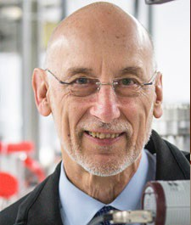
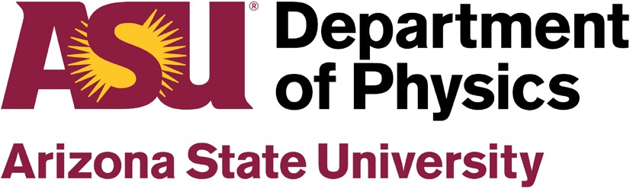 COLLOQUIUM

...

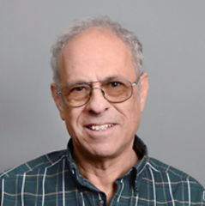
Thursday, October 21st, 2021

4:00 PM – 5:00 PM, Virtual

https://asu.zoom.us/j/86960690591

What is the Science behind

Climate Change?

Professor Peter Rez

Arizona State University

Department of Physics

Abstract:
Not a day goes by when we don’t hear about the “climate crisis”; some effects are well documented, like the rise in the average global temperature and the shrinking of the polar ice caps. Undoubtedly, carbon dioxide levels in the atmosphere have been increasing, but what does “science” say about the potential consequences? The combination of the atmosphere, oceans, cryosphere and biosphere is the ultimate non-linear coupled complex system. How well do we understand what might happen? In the first part of my talk, I shall review my exploration of the original literature to try and separate out speculation, hypothesis, results of computational models, and most significantly actual observations. In the second part of my talk, I shall discuss what will actually work to reduce carbon dioxide emissions (complete elimination or Net Zero is an impossibility). Although it has become fashionable for governments to impose mandates enshrined in laws, the only laws that matter are the laws of thermodynamics and Ohm’s law.

Biography:
Peter Rez was an undergraduate in Cambridge and received his doctorate in Oxford. His expertise is in the physics of electron and X-ray scattering, mainly applied to electron microscopy and spectroscopy but also applied to radiation detectors and medical physics. He is responsible for scattering cross sections used in quantitative EELS analysis and was involved in the development of theoretical models to understand EELS inner shell fine structure. He has also worked on modeling of battery and other materials. Early thesis work on phonon scattering in electron microscopy has been revived both for quantitative calculations of ADF contrast and to provide a framework for analysing the results for ultra-high resolution EELS on the nanometer scale. Since his 3rd kidney stone, he developed an interest in biomineralization, applying advanced microscopy and solid state modeling to urolithiasis, and making the transition from victim to invited speaker in a urology conference in 2 years! This lead to work on normal biomineralization, the formation of calcite shells. This has been the subject of a long-standing collaboration with the world leaders in this field at the Weizmann Institute. He has also commented on issues where physics affects society at large, both in the deployment of X-ray based body scanners at airports (since abandoned) and more recently on energy policy, that is the subject of his book “The Simple Physics of Energy Use”.

Host: Prof. David Smith
View our Fall 2021 Physics Colloquium schedule at https://physics.asu.edu/colloquia

